Review Article

Title (14 pt, bold, times new roman)

Author name¹, Author name² (Times New Roman, 10 pt, bold)

¹Author affiliation (Times New Roman, 8 pt)
²Author affiliation
*Corresponding: m.akrom@dsn.dinus.ac.id

Abstract (Times New Roman, 10 pt, bold)
A single paragraph, maximum 200 words. Abstract content must contain (1) an overview of the object of research, (2) problems and research objectives, (3) methods, (4) main findings and results, (5) novelty/originality/value, and (6) conclusions. (Times New Roman, 10 pt)

Keywords: keyword1, keyword2, ….. , keyword6. (Times New Roman, 10 pt)

Received Month 20xx / Revised Month 20xx / Accepted Month 20xx / Published Month 20xx

© 2026 by the authors. This publication is licensed under the terms and conditions of the Creative Commons Attribution (CC BY) license (https://creativecommons.org/licenses/by/4.0/).

- INTRODUCTION (Times New Roman, 10 pt, bold)
The introduction must contain the background, and literature review (state of the art) to show the results and findings of previous research and indicate the main limitations of previous research.
The introduction must clearly state the importance of this research compared to previous research (gap analysis), and the main problems of this research (novelty).

- METHODS
The method must explain the procedures for obtaining data and data analysis techniques. The research stages and analysis must be explained in detail.
  - Subsection 1
The method must explain the procedures for obtaining data and data analysis techniques. The research stages and analysis must be explained in detail.
  - Subsection 2
The method must explain the procedures for obtaining data and data analysis techniques. The research stages and analysis must be explained in detail.

- RESULT AND DISCUSSION
Results and discussion are presented in the same, clear, and concise section to avoid long quotations. Tables, graphs, or pictures can be presented to clarify research results. The discussion must include an analysis of the research results. Comparisons with previous research findings should be included.

- CONCLUSION
The conclusion is written in one paragraph, presented briefly, narratively, without points, and conceptually. The impact of the research must be stated.

REFERENCES
References must follow IEEE style. We strongly recommend preparing references with a bibliography software package such as Mendeley, EndNote, or Zotero to avoid typos and duplicate references. Include a digital object identifier (DOI) for all references if available.

Below is an example of a bibliography:
[1] M. Akrom, S. Rustad, A.G. Saputro, A. Ramelan, F. Fathurrahman, and H.K. Dipojono. 2023. A combination of machine learning model and density functional theory method to predict corrosion inhibition performance of new diazine derivative compounds. Materials Today Comm., 35(7), 106402-106408. https://doi.org/10.1016/J. MTCOMM.2023.106402. [for journal article]
[2] M. Akrom, T. Sutojo, A. Pertiwi, S. Rustad and H.K. Dipojono. 2023. Investigation of best QSPR-based machine learning model to predict corrosion inhibition performance of pyridine-quinoline compounds, in The 4th Engineering Physics International Conference 2023 (EPIC 2023) 26/09/2023 - 27/09/2023 Bandung, Indonesia. Journal of Physics: Conf. Ser., 2673, 012014. DOI 10.1088/1742-6596/2673/1/012014. [for proceeding article]
[3] L. Bass, P. Clements, and R. Kazman. 2003. Software Architecture in Practice, 2nd ed. Reading, MA: Addison Wesley, 2003. [E-book] Available: Safari e-book. [for book]
[4] J.O. Williams. 1993. Narrow-band analyzer, Dissertation, Dept. Elect. Eng., Harvard Univ., Cambridge. [for thesis/dissertation]

NOTES:
- Image and table formats using center alignment. Each figure and table is given a number and description and refers to the text. The image number and title are placed below the image.

Table 1. Comparison of the model performance before and after adding polynomial function
Model | RMSE
Model | Training | Testing
NuSVR | 18.96 | 7.41
NuSVR + Polynomial | 10.16 | 3.87

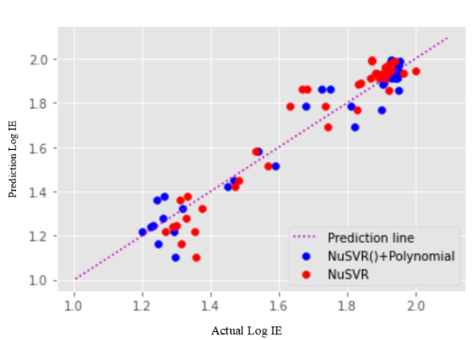
Figure 2. Scatter plot of model performance before and after adding polynomial function

