INTERPRETATIVE PHENOMENOLOGICAL ANALYSIS OF THE
DIFFERENCE BETWEEN THE DEPICTION OF ONI ACCORDING TO
JAPANESE UKIYO-E PAINTINGS AND THE DEPICTION OF ONI IN THE ANIME "KIMETSU NO YAIBA" BY KOYOHARU GOTOUGE
¹Revico Allesy, ²Tri Mulyani Wahyuningsih
¹Dian Nuswantoro University, Semarang, Indonesia
²Dian Nuswantoro University, Semarang, Indonesia
(revicoallesy@gmail.com)

Abstract. This research is about "the difference between the depiction of the appearance of oni according to Japanese Ukiyo-e paintings and the depiction of oni in the anime Kimetsu no Yaiba". The aim of this research is to look for differences in the depiction of the appearance of oni depicted in Ukiyo-e paintings with the appearance of the oni found in anime "Kimetsu no Yaiba". The data for this research are pictures of oni on the Ukiyo-e website and the shounen anime about demon hunters, namely "Kimetsu no Yaiba". This research uses qualitative methods with observation and data classification. The stages of data analysis techniques include data reduction, data display, data interpretation, and drawing research conclusions. Based on the analysis, research results were obtained in the form of differences in the depiction of Oni in Ukiyo-e paintings and Oni in the anime "Kimetsu no Yaiba" in terms of their physical appearance and the way they dress. The appearance of Oni according to Japanese Ukiyo-e paintings is that men have red skin, their appearance is only wearing a loincloth made of animal skin, female Oni (kijo) have an ugly face and have blue skin with tattered clothes. Meanwhile, the male oni in the anime "Kimetsu no Yaiba" has a physical appearance with pale white skin, wearing a suit and wearing a hat. Female oni (kijo) have pale white skin and wear patterned kimono clothes.
Keywords: culture, oni, japan, yokai, anime

RESEARCH BACKGROUND
Folklore is part of the culture of a group or region that is spread and passed down from generation to generation, is traditional, and has different versions (Danandjaja, 1994, p.2). Folklore itself is not only oral literature, such as folklore, but traditional dance, traditional architecture and historical places are also included in the folklore category.
Yokai is a folklore or mythological creature in Japan. In the early 20th century, folklorist Ema Tsutomu explain about yokai as mysterious and strange (Reider. 2012 p. 189). Yokai have various forms such as animals, fire, and some are even shaped like humans. Yokai have the ability to change their shape to become whatever they want. From people's stories, Yokai like to come suddenly and disappear suddenly too. Yokai are also described as having extraordinary abilities, both physical and magical abilities. Yokai are said to be able to harm anyone and anywhere, according to their own wishes. Yokai were first used and became popular as depicted in fairy tales and legends (Papp, 2010)
If examined from the Kanji letters, Yokai (妖怪) comes from Kanji (妖/you) which means
"interesting" and Kanji (怪/ayashii) which means "occult or strange". Therefore, it can be interpreted that youkai are strange supernatural creatures, but have something interesting about them. Yoda and Alt (2012) reveal the image of yokai to foreign readers, namely that yokai are often called devils, ghosts, goblins and specters, namely Japanese creatures with strange shapes that live in other worlds. In my opinion, yokai are different. For example, people still think that Yokai is the same as Yuurei (幽霊). In my opinion, this cannot be equated because Yokai are mythological creatures while Yuurei are spirits of dead people who have hatred or regret in this world so they cannot go to heaven. The depiction of Yokai in society varies because there is not just one type of Yokai. For example, people who live in the mountains will see Yokai who live in the mountains like Tengu. Such a work on yokai research is Yōkai Dangi (Discourse on yokai) by Yanagita Kunio (2013), the founder of Japanese folklore studies. The earliest essay in the book, written in 1909, focuses on the tengu legend through its perspective on the search for “mountain people.” Then people who live near rivers will see Yokai in river areas such as Kappa which is described as a scaly, slimy, greenish yokai, webbed feet and hands, and has a turtle shell on its back and even resembles a child in size. however the proportions are highly distorted (Foster, 2015). The way to describe what they look like is by hearing the characteristics from word of mouth of Japanese society from ancient times and even today. People at that time also depicted Yokai with paintings according to the characteristics discussed by people at that time. These paintings are usually painted using a painting technique called the Ukiyo-E technique. Ukiyo-E itself is a painting technique developed during the Edo period where paintings usually depict daily life in society at that time. Other groups of artists also created new trends, taking forms derived from European styles and abandoning traditional factors. Ultimately, these efforts stopped, due to the country's isolation policy. However, this policy did not have much influence on the existence of painting schools at that time (Iswidayati, 2006). Plus, nowadays there is a culture that depicts yokai in a light way with a more modern model, namely anime. More simply, popular culture is defined as culture that many people like, works that are done to please people, such as Japanese popular culture such as manga and anime (Storey: 2003). With anime, the character of each existing yokai can be conveyed easily and easily for all groups. I am interested in this research because I like mystical things and focus on that because it is better for someone to do just one job and do it as well as possible (wahyuningsih, 2016)

REVIEW OF RELATED LITERATURE
After the researcher reviewed several studies, research can be found that matches what the researcher is looking for. The research that researchers managed to find was research conducted by Retno Dewi Ambarastuti (2018) entitled "Depicts of Youkai in Japanese Literature from the Joudai Period to the Modern". The aim of this research is to focus on the depiction of youkai characters in Japanese literature from the ancient to the modern period. From this research, researchers got a picture of yokai in the Edo period. The reason why the Edo period was chosen is because Ukiyo-e paintings were famous during that period.

RESEARCH METHOD
The used method is a method that describes qualitative data descriptively, namely the descriptive qualitative method with observation and data classification. Agreeing to Mukhtar (2013: 10) the subjective graphic inquire about strategy may be a strategy utilized by analysts to discover information or hypotheses around investigate at a certain time. Through this method the author tries to reveal the differences between the depiction of Oni in Ukiyo-e paintings and the Oni in the anime "Kimetsu no Yaiba" seen from their physical appearance and the way they dress.

RESULTS AND DISCUSSION
Here the researcher will explain the differences in the depiction of oni in Ukiyo-e paintings and the anime Kimetsu no Yaiba. This significant difference can explain how fast developments in the art of painting have progressed over time.
The differences between oni include:
- Clothes
- Skin
- Eyes
- Nails
- Horns

Clothes
The most visible difference is the way they dress. From the way you dress, you will see how the image of an oni develops in both Ukiyo-e paintings and the anime Kimetsu no Yaiba.

Skin
The difference in skin color itself can also be a comparative value because as time advances, the coloring of an image or painting will become more diverse.

Eye
Even though the eyes are a small thing in a work of painting, that doesn't mean the eyes are a small thing because from the eyes we can see the difference in the way the oni character looks.

Claws
Claws are a simple thing but interesting to discuss, especially what we will discuss is the difference in claws that oni have, because oni themselves are demons who have sharp nails and are often depicted in paintings and other fine arts.

Horn
Horns are a characteristic characteristic of oni or what can be called devils. It could be said to be a unique characteristic because humans do not have horns and animals usually have their own horns. However, oni have horns on their heads.
Differences
The results found in this study are the differences of ukiyo-e’s oni and kimetsu no yaiba’s oni appearance which include clothes, skin, eyes, claws, and horns.

Differences type table of kimetsu no yaiba’s oni appearance
Type of Differences | Action
Clothes | Oni has neat clothes
Skin | Oni has pale white skin color
Eyes | Oni has blood red eyes
Claws | Oni has black sharp claws
Horn | Oni has one crooked horn in her head

Differences type table of Ukiyo-e’s oni appearance
Type of Differences | Action
Clothes | Oni has shabby and made from animal skin clothes
Skin | Oni has gray skin color
Eyes | Oni has dark yellow eyes
Claws | Oni has white claws
Horn | Oni has one straight horn in her head

Clothes
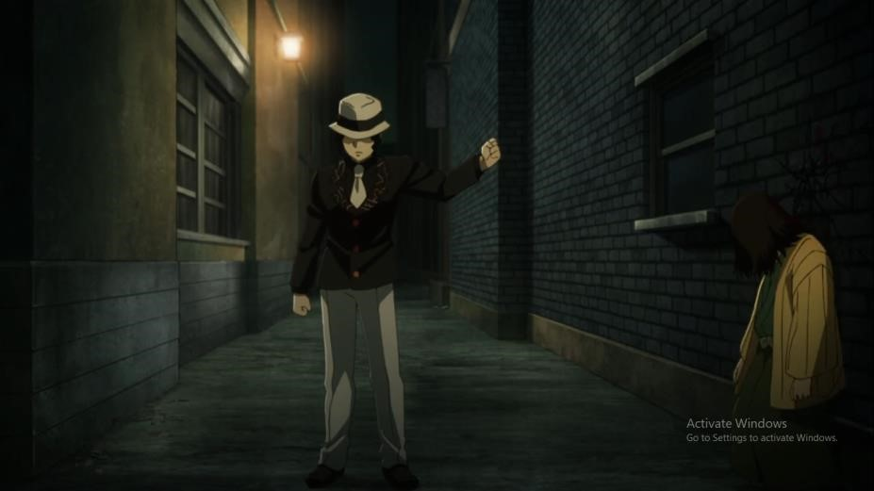
Figure 1 Oni clothing in the anime "Kimetsu no Yaiba"
[Source: Anime Kimetsu no Yaiba. 2019. Episode 8. 07:10]
The picture above shows that the oni or devil in the Anime Kimetsu no Yaiba named Muzan is wearing more modern clothes. In accordance with the anime's time setting, it was taken during the Taisho period around 1912 to 1926 in Japan. The clothes worn by Oni are very neat to look at. With a white fedora hat and wearing a black suit complete with a white tie and wearing white trousers

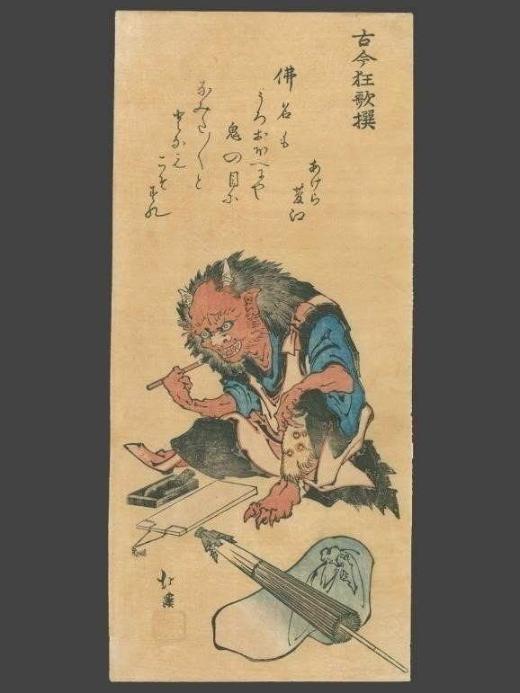
Figure 2 . Oni clothing in Ukiyo-E paintings
[Source: https://ukiyo-e.org/image/artofjapan/08134321]
In the picture above you can see an oni preparing something. The image above is an ukiyo-e painting by Totoya Hokkei in 1830 with the title "An Oni Preparing to Write in an Account Book". Here the oni wear very shabby and disheveled clothes. His clothes were made of blue cloth which looked very untidy and he was wearing trousers made of black cloth which looked to have been cut. Oni wear loincloths made from wild animal skin (usually made from tiger or bear skin) as their underwear.

Skin
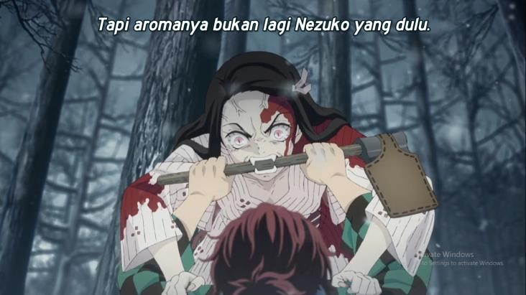
Figure 3 . Kijo's skin in the anime "Kimetsu no Yaiba"
[Source: Anime Kimetsu no Yaiba. 2019. Episode 1. 10:39]

You can see in the picture above that Kijo or a female oni named Nezuko is losing control due to her transformation from human to oni due to Muzan's actions and attacking her own brother, Tanjiro. Here there is a physical change in Nezuko that can be seen, namely his skin color. Nezuko's skin color is pale white with veins all over her face. Before becoming an oni, Nezuko had the skin color of an ordinary human, but everything changed when she became an oni.
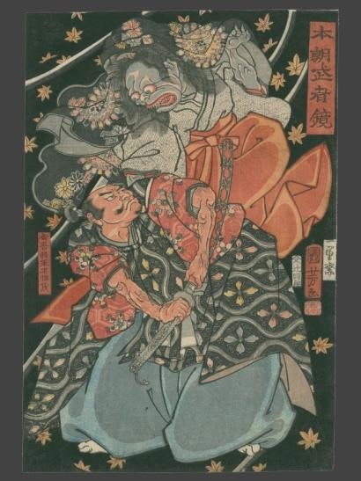
Figure 4 . Kijo skin in Ukiyo-E painting
[Source: https://ukiyo-e.org/image/mfa/sc162667]
You can see in the picture above that Kijo or female oni is fighting a swordsman named Taira Koremochi. This ukiyo-e painting was painted by Tsukioka Yoshitoshi in 1887 with the title "Taira Koremochi Vanquishes a Female Demon at Togakushi Mountain (Taira Koremochi Togakushiyama kijo taiji no zu)". In the painting, Kijo has an ugly and old face. Unlike the anime version which has pale white skin, in this painting Kijo has gray or pale blue skin. This skin color is what differentiates Kijo and ordinary Oni because ordinary Oni have bright red skin. Eyes
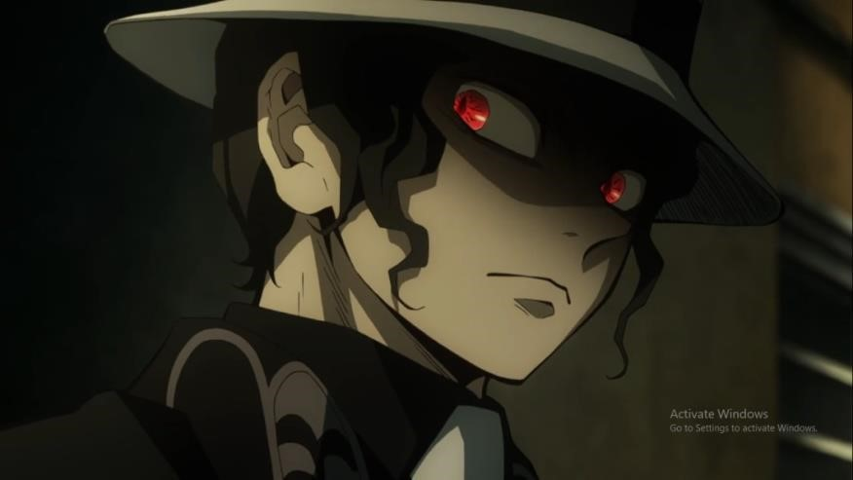
Figure 5 . Oni eyes in the anime "Kimetsu no Yaiba"
[Source: Anime Kimetsu no Yaiba. 2019. Episode 8. 09:15]
You can see in the picture above, Muzan or oni in the Anime Kimetsu no Yaiba has a pair of eyes like a monster. He had a pair of blood-red eyes that emitted an extremely evil aura. The way Muzan looks looks very sharp and indicates that he is a very cruel creature and has no sense of mercy.
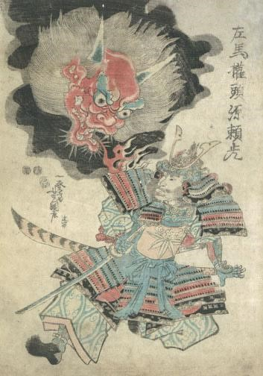
Figure 6 . Oni eyes in Ukiyo-E paintings
[Source: https://ukiyo-e.org/image/robynbuntin/5272-7]
In the painting, the oni's face is clearly depicted. This Edo period painting was created in 1852 by Utagawa Yoshitsuna with the title "Raiko and Shuten Doji". This painting was created to depict the battle fought by Minamoto no Raiko against Shuten Doji which was ultimately won by Shiuten Doji the oni. According to the painting, the oni's eyes are dark yellow and glaring. Even though he was glaring, his eyes were very sharp and full of anger when he looked at Minamoto no Raiko. Claws
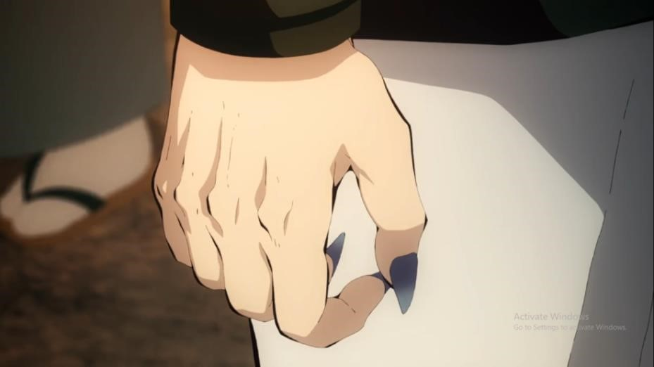
Figure 7 . Oni claws in the anime "Kimetsu no Yaiba"
[Source: Anime Kimetsu no Yaiba. 2019. Episode 7. 20:41]
In the picture above, Muzan's claws are shown to attack humans to become new oni. Muzan's power can turn ordinary humans into oni through Muzan's blood which flows through his claws. When Muzan sticks his claws into a human body, there are two possibilities, namely that he can turn into an oni, or explode into small pieces of flesh. The characteristics of Muzan's claws are that they are slightly bluish black in color with sharp tips for tearing his opponent apart or sticking his fingers into someone's body to turn them into an oni.
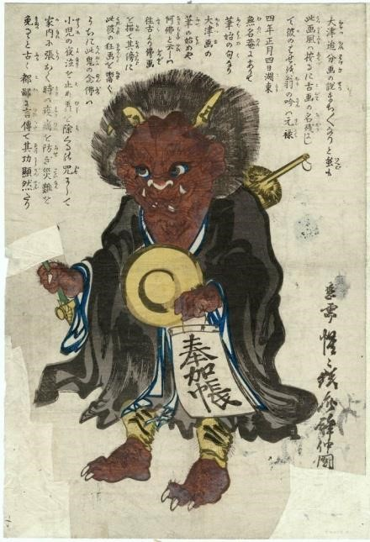

Figure 8 . Oni claws in Ukiyo-E paintings
[Source: https://ukiyo-e.org/image/mfa/sc143481]
It is depicted in the painting above that the oni does have claws on its hands and legs. This ukiyo-e painting was created by Kawanabe Kyosai in the Edo period, namely in the 1860s, with the title "otsu-e..Figure:..Demon..Converted..to..Buddhism..(Oni.no.nenbutsu)". In this painting, the oni has very sharp claws on its hands. Its claws are white like its fangs. Likewise with his feet, he also has claws on each toe on his feet which makes it even more scary if we see him in person.

Horns
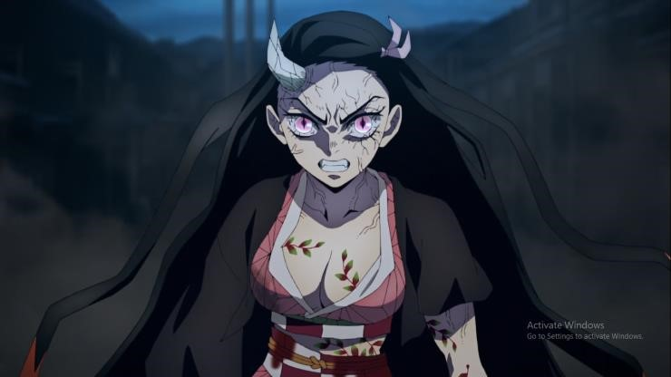
Figure 9 . Kijo's horns in the anime "Kimetsu no Yaiba"
[Source: Anime Kimetsu no Yaiba.Yuukaku Hen. 2021. Episode 7. 00:27]
The picture above was taken when Nezuko showed her oni form to her enemies in order to help her brother eradicate the evil oni. In the picture, Nezuko is shown looking angry with her very sharp pink eyes. His face was full of muscles which made him even scarier. And what stands out about Nezuko is her horns. Nezuko has 1 horn growing from his forehead. Usually a pair of horns grow from an animal's head, but Nezuko's Kijo form only has 1 horn. The horns are bone white in color with a design like cracks on the horns that bend upwards.
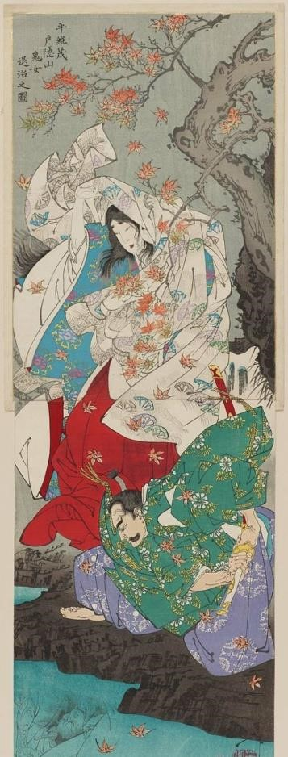

Figure 10 . Kijo horns in Ukiyo-E paintings
[Source: https://ukiyo-e.org/image/mfa/sc162667]

The painting above has similarities to the horns that Nezuko has from the anime "Kimetsu no
Yaiba". The similarity is that Kijo in the painting by Tsukioka Yoshitoshi in 1887 with the title
"Taira Koremochi Vanquishes a Female Demon at Togakushi Mountain (Taira Koremochi Togakushiyama kijo taiji no zu)" also has 1 horn on her head. In the painting, there are clearly two people, namely a man with a sword named Taira no Koremochi and a beautiful woman wearing a white kimono. However, the woman is actually a Kijo or oni woman whose true form we can see in the reflection of the water. Even though they both have one horn, their horns are different, namely that Kijo's horns are pointed and rise straight upwards, unlike Nezuko's horns which are bent.

CONCLUSION
In accordance with the research above, it can be concluded that developments over time, both in the form of art, also influence the image or characteristics of an oni. The Ukiyo-E painting depicts oni in accordance with what people at that time believed in their traditional clothes, even the oni in Ukiyo-E paintings are seen still wearing the skin of wild animals such as tigers or bears as clothes. In contrast to the oni or kijo in the anime Kimetsu no Yaiba. In this anime, the characteristics and appearance are changed to be more modern, both from the form which mostly still looks like a human with very pale skin, even the clothes are also made more modern with suits, hats, shoes and even muzan, the oni in the anime Kimetsu no Yaiba also wear a tie. Whether Ukiyo-E or Anime paintings, depictions of oni and kijo are made in accordance with current developments in fine arts in order to please the eyes of those who see or watch them. Even if you look at it from an artistic medium, Ukiyo-E paintings have their own aesthetic which makes them a distinctive feature of traditional Japanese painting. Likewise with anime which is a medium to entertain the audience with the beauty presented in every scene in the anime.

REFERENCES
Danandjaja, James. 1994. Folklor Indonesia. Jakarta: Pustaka Utama Grafiti.
Papp, Zilia. 2010. Anime and Its Roots in Early Japanese Monster Art.
Kent: Global Oriental.
Yoda, Hiroko dan Matt Alt. 2012. Yokai Attack!: Japanese Monster Survival Guide.
Singapore: Tuttle Publishing.
Ratna, Nyoman Kutha. 2004. Teori, Metode, dan Teknik Penelitian Sastra. Yogyakarta: Pustaka Pelajar
Yanagita Kunio. 2004. Tōno monogatari.
Tōkyō:Kadokawa.
Foster, M. D. (2015). The Book of Yokai: Mysterious Creatures of Japanese Folklore.
California: University of California Press.
Wibert E. Moore, Sociale Verandering dalam Social Change, diterjemahkan oleh A. Basoski, Prisma
Boeken.
(Antwepen: Utrecht, 1965), h. 129.
Iswidayati,S. 2006. Seni Lukis Kontemporer Jepang dalam Kajian Semiotik.
Semarang: UNNES Press
Reider, N. (2010). Japanese Demon Lore.
Logan, Utah: Utah State University Press.
Storey, John. 2003. Teori Budaya dan Budaya Pop.
Yogyakarta: Penerbit Qalam.
Wahyuningsih, T. M., & Aryanto, B. (2016). Implemantasi Budaya Kerja 5 S dan Hourensou oleh Para Eks-pemagang di Jepang dalam Dunia Kerja di Indonesia.

