Parallelism in Nursery Rhymes
HettyCaturEllyawati
Universitas Semarang
catur@usm.ac.id

Parallelism is a way to make your writing and speaking become more interesting and clear. Some of poetry writers and public speakers use this method to make their writings or speeches easy to remember. Another writing using parallelism is nursery rhymes. This research aims to find out the use of parallelism in nursery rhymes in ABCKidsinc. The method used to collect data is purposive random sampling, meanwhile in analysing data, I use descriptive method. The result of this research is there is a use of parallelism in nursery rhyme in ABCKidsinc. It is not only in vocabulary and sound but also in grammar.
Keywords: parallelism, nursery rhymes, vocabulary, sound, grammar

INTRODUCTION
People always try to make theirselves to be listened to (Amardeep, 2017). They want some attention either in their writing or in their speech. They do everything to make it happens. Some methods are applied, some techniques have been done. A way to make it easy to remember, easy to listen, and easy to understand is by doing repetition in some words, sound or structures of sentences. The repetition is done not only to make the writing or the speech interesting but also fun to listen to. Some people call the technique as parallelism.

Parallelism
The oldest term of parallelism is found in ancient Hebrew Literature (Encyclopaedia Britanica, 2018) in the early 12th century BC appeared as a poetry that was based on the principle of parallelism, they were two halves of verse express the same idea, either by repeating the word in different vocabulary or by stressing different aspects of the word. While Wales (2001) said there are repetitive patterns on levels of sound, syntax, lexis and meaning that lead to unity. That the unity parts are to interconnect each part of a text so that the text finally succeeds becomes a whole without any loss of meaning (Bloomfield, 1976). It means to coordinate ideas in phrases, sentences and or paragraphs in a text, it has to be equaly important and similar.
There are some kinds of parallelism, they are phonological parallelism, morphological parallelism, grammatical parallelism or syntactical parallelism, and lexical or semantic parallelism.

Phonological Parallelism
Phonological parallelism is about repetition of similar sounds includes assonance, alliteration, consonance and rhyme. Assonance is repetition of vowel sounds, for example uncertain and curtain, while alliteration is repetition of consonant sounds at the beginning of the words, such as Luna Love good. Consonance is repetition of the same consonant several times in a row, for example humpty dumpty. Rhyme is repetition of similar sounding words. There are a lot of different types of rhyme, like “tap”and “map”, “best” and “worst”.
a. Place of Articulation
1). Consonant
In many words repetition, it is not only lexical aspect which is repeated but also syntax and sound. For sound, there is place of articulation that is so much different between consonants and vowels. For consonant, the place of articulation for its sound is:

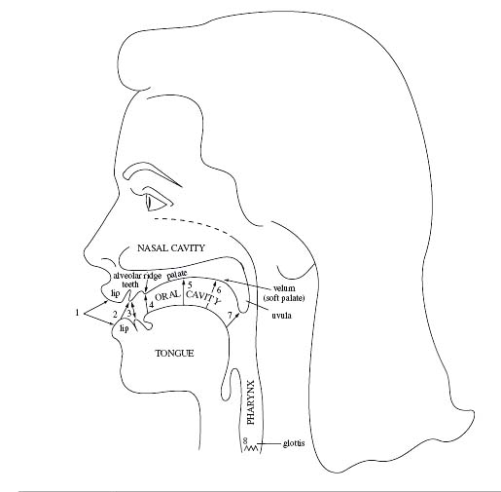
Figure 1. The vocal tract. Place of articulation: 1. Bilabial, 2. Labiodental, 3. Interdental, 4. Alveolar, 5. Palatal, 6. Velar, 7. Uvular, 8. glottal
- Bilabials : [p] [b] [m], produced by bringing both lips together
- Labiodentals : [f] [v] , produced by touching the bottom lip to the upper teeth
- Interdentals : [θ] [ð], produced by putting the tip of the tongue between the teeth.
- Alveolars : [t] [d] [n] [s] [z] [l] [r] , All of these are produced by raising the tongue to the alveolar ridge in some way.
- [t, d, n]: produced by the tip of the tongue touching the alveolar ridge (or just in front of it)
- [s, z]: produced with the sides of the front of the tongue raised but the tip lowered to allow air to escape
- [l]: the tongue tip is raised while the rest of the tongue remains down so air can escape over the sides of the tongue, thus [l] is a lateral sound.
- [r]: air escapes through the central part of the mouth; either the tip of the tongue is curled back behind the alveolar ridge or the top of the tongue is bunched up behind the alveolar ridge
- Palatals: [ʃ][ʒ][ʧ][ʤ][ʝ], Produced by raising the front part of the tongue to the palate
- Velars: [k] [g] [ŋ], Produced by raising the back of the tongue to the soft palate or velum
- Uvulars : [ʀ] [q] [ɢ],Produced by raising the back of the tongue to the uvula
- Glottals : [h] [Ɂ], Produced by restric0ng the airflow through the open glottals ([h]) or by stopping the air completely at the glottis (a glottal stop [Ɂ].
Table 1. Example of Consonants in English Words
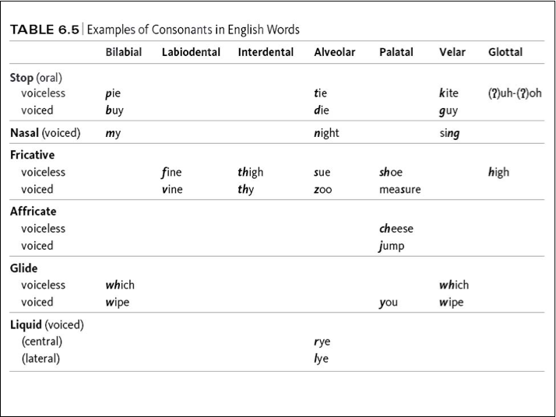
2). Vowels
vowels are classified by how high or low the tongue is, if the tongue is in front or back of the mouth, and whether or not the lips are rounded.
High vowels: [i] [ɪ] [u] [ʊ]
Mid vowels: [e] [ɛ] [o] [ə] [ʌ] [ɔ]
Low vowels: [æ] [a]

Front vowels: [i] [ɪ] [e] [ɛ] [æ]
Central vowels: [ə] [ʌ]
Back vowels: [u] [ɔ] [o] [æ] [a]

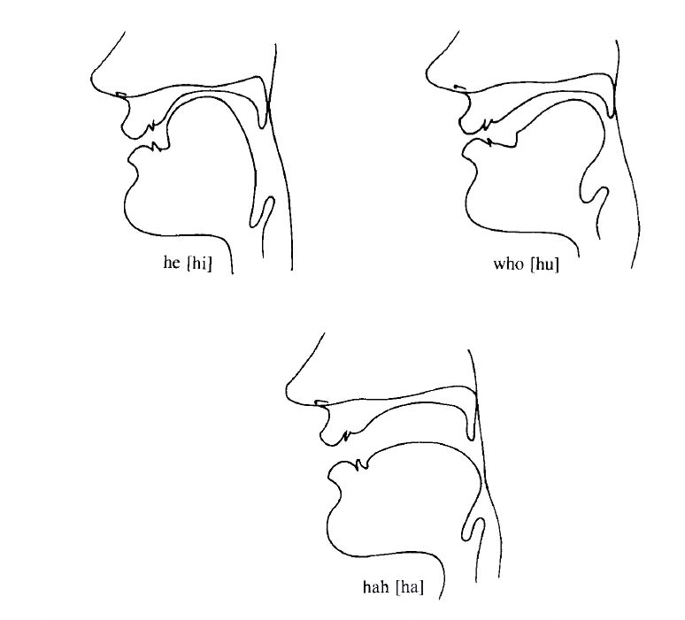
Figure 2. Vowels Articulation
According to how the vowels produced, there are:
a. Round vowels: [u] [ʊ] [o] [ɔ]
  - Produced by rounding the lips
  - English has only back round vowels, but other languages such as French and Swedish have front round vowels.
- b. Diphthongs: [aɪ] [aʊ] [ɔɪ]
- A sequence of two vowel sounds (as opposed to the monophthongs we have look at so far)
c. Nasalizatio

- Vowels can also be pronounced with a lowered velum, allowing air to pass
through the nose
  - In English, speakers nasalize vowels before a nasal sound, such as in the words beam, bean, and bingo
  - The nasalization is represented by a diacritic, an extra mark placed with the symbol

Table 2. Vowels Part of The Tongue Involved
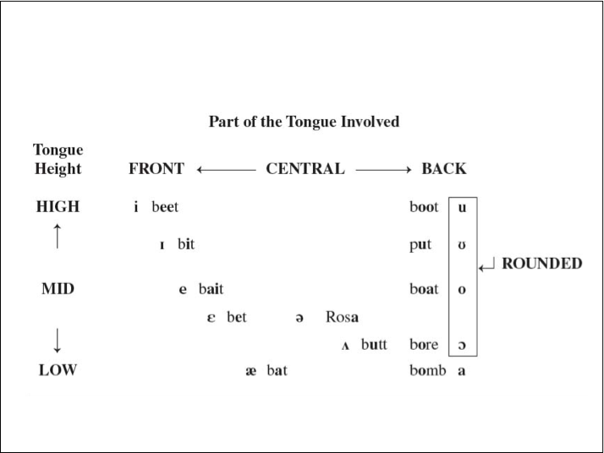

Morphological Parallelism
It is about repetition of morphems, for example “I walked, I talked”. Repetition in tensed morpheme “ed”.

Grammatical/Syntactical Parallelism
This parallelism is focus more to something relate to grammar. There are some sub division of this parallelism, they are sentence parallelism, main clause parallelism, sub-clause parallelism, phrase parallelism and word parallelism.
Sentence
Main Clause
Sub-Clause
Phrase
Word
Figure 3. Levels of Syntactic Parallelism

Lexical Parallelism/Semantic Parallelism
Sakamoto (1982) in his article said that lexical parallelism is repetition of lexical items that indicates the sentences connection in a text. It may be identical in form and meaning, or may be related by lexico-semantic relationship, such as synonymy, hyponymy, antonymy. For examples: I like swimming, hiking, reading, and jogging.

Nursery Rhymes
Nursery rhyme according to Meriam-Webster (2018) is a short rhyme for children that often tells a story. While in Encyclopaedia Britanica (2018), nursery rhyme is verse that customarily told or sung to small children.
Parallelism is found not only in literature such as poem and poetry but also in songs, for example songs for children (Nursery Rhymes). Parents sometimes make their children to listen to a song in order to improve their vocabularies. By listening to a song, the children can easily understand the meaning and memorize the vocabularies because they have special rhythm and many words repetition to stimulates the children’s brain to catch the lyrics (Devi, 2009).
METHOD
There are two methods I used in this journal, the first is method to collect the data and the second is method to analyse data. The method to collect data I used is purposive random sampling because I only need data that relate to my research, that is parallelism. The data I got from ABCKidsinc that contains many popular kids songs or nursery rhymes are about 50 songs but only 16 songs I analysed. There are a few steps that I need to consider when I did data collection, they are listening to the songs, grouping the songs with parallelism, selecting the songs with different and similar parallelism, and analyising the data. While in analysing the data, I have several steps, first I grouped the song in different parallelism, such as vocabulary, sound and grammar. Second I tried to find how many songs with those differences then I analysed the similarities and the differences of each group of the song.
RESULT AND DISCUSSION
From 16 songs I listed at ABCKidsinc, there are about 317 lyrics. The use of parallelism within its variation is below in Table 3.
Table 3.The Result of Analysis
Number of Song | Lyrics | Parallelism
 |  | Phonological | Syntactical | Lexical
16 | 317 | 12 | 2 | 2
It can be seen from the table that the most parallelism occurance is on phonological parallelism while the second is on lexical parallelism and the last is on syntactical.
For the all result of the analysis, see below:

Table 5. Data 1. Title of Song: Baa, Baa, Black Sheep
No. | Lyrics | Kinds of Parallelism: Sound
a | Baa, baa, black sheep, | Alliteration
b | Have you any wool? | Assonance
c | Yes sir, yes sir,
d | Three bags full. | Assonance
e | One for my master, | Syntactic
f | One for my dame, | Assonance
g | And one for the little boy | Syntactic
h | Who lives down the lane. | Assonance
Table 6. Data 2. Title of Song: Bingo was His Name-O
No. | Lyrics | Kinds of Parallelism: Sound
a | There was a farmer had a dog | Assonance
b | and bingo was his name-o | Assonance
c | Bingo
d | Bingo
e | Bingo
f | and bingo was his name-o | Assonance
Table 7. Data 3. Title of Song: Hickory Dickory Dock
No. | Lyrics | Kinds of Parallelism: Sound
a | Hickory Dickory Dock, | Rhyme
b | The mouse ran up the clock. | Rhyme
c | The clock struck one, | Assonance
d | The mouse ran down! | Assonance
e | Hickory Dickory Dock. | Rhyme
f | Hickory Dickory Dock, | Rhyme
g | The mouse ran up the clock. | Rhyme
h | The clock struck two, | Assonance
i | The mouse said boo! | Assonance
j | Hickory Dickory Dock. | Rhyme
k | Hickory Dickory Dock, | Rhyme
l | The mouse ran up the clock. | Rhyme
m | The clock struck three, | Assonance
n | The mouse said wee! | Assonance
o | Hickory Dickory Dock. | Rhyme
p | Hickory Dickory Dock, | Rhyme
q | The mouse ran up the clock. | Rhyme
r | The clock struck four, | Assonance
s | The mouse said no more! | Assonance
t | Hickory Dickory Dock.
Table 8. Data 4. Title of Song: Hot cross buns
No. | Lyrics | Kinds of Parallelism:
a | Hot cross buns, Hot cross buns,
b | one a penny, two a penny, | Lexical
c | hot cross buns,
d | If you have no daughters, | Lexical
e | give them to your sons, | Lexical
f | one a penny, two a penny, | Lexical
g | Hot Cross Buns.
Table 9. Data 5. Title of Song: Hush, little baby
No. | Lyrics | Kinds of Parallelism: Sound
a | Hush, little baby
b | Mama's gonna buy you a mockin'bird
c | If that mockin'bird don't sing | Assonance
d | Mama's gonna buy you a diamond ring | Assonance
e | If that diamond ring turns brass, | Assonance
f | Mama's gonna buy you a looking glass | Assonance
g | If that looking glass gets broke | Assonance
h | Mama's gonna buy you a billy goat | Assonance
i | If that billy goat don't pull, | Assonance
j | Mama's gonna buy you a cart and bull | Assonance
k | If that cart and bull turn over, | Assonance
l | Mama's gonna buy you a dog named Rover | Assonance
m | If that dog named Rover won't bark, | Rhyme
n | Mama's gonna buy you a horse and cart | Rhyme
o | If that horse and cart fall down, | Assonance
p | Then you'll be the sweetest little baby in town. | Assonance
Table 10. Data 6. Title of Song: The Itsy Bitsy Spider
No. | Lyrics | Kinds of Parallelism: Sound
a | The itsy bitsy spider climbed up the water spout | Assonance
b | Down came the rain, and washed the spider out | Assonance
c | Out came the sun, and dried up all the rain | Assonance
d | So the itsy bitsy spider climbed up the spout again. | Assonance
e | IncyWincy Spider climbed up the tree | Assonance
f | Down came the snow and made poor Incy freeze | Assonance
g | Out came the sunshine, and melted all the snow | Assonance
h | So IncyWincy Spider had another go | Assonance
Table 11. Data 7. Title of Song: London Bridge is Falling Down
No. | Lyrics | Kinds of Parallelism:
a | London Bridge is falling down, | Syntactic
b | Falling down, Falling down. | Syntactic
c | London Bridge is falling down, | Syntactic
d | My fair lady. | Syntactic
e | Take a key and lock her up, | Syntactic
f | Lock her up, Lock her up. | Syntactic
g | Take a key and lock her up, | Syntactic
h | My fair lady. | Syntactic
i | How will we build it up, | Syntactic
j | Build it up, Build it up? | Syntactic
k | How will we build it up, | Syntactic
l | My fair lady? | Syntactic
m | Build it up with silver and gold, | Syntactic
n | Silver and gold, Silver and gold. | Syntactic
o | Build it up with silver and gold, | Syntactic
p | My fair lady. | Syntactic
q | Gold and silver I have none, | Syntactic
r | I have none, I have none. | Syntactic
s | Gold and silver I have none, | Syntactic
t | My fair lady. | Syntactic
u | Build it up with needles and pins, | Syntactic
v | Needles and pins, Needles and pins. | Syntactic
w | Build it up with needles and pins, | Syntactic
x | My fair lady. | Syntactic
y | Pins and needles bend and break, | lexical
z | Bend and break, Bend and break. | lexical
a.1 | Pins and needles bend and break, | lexical
b.1 | My fair lady. | lexical
c.1 | Build it up with wood and clay, | lexical
d.1 | Wood and clay, Wood and clay. | lexical
e.1 | Build it up with wood and clay, | lexical
f.1 | My fair lady. | Syntactic
g.1 | Wood and clay will wash away, | Syntactic
h.1 | Wash away, Wash away. | Syntactic
i.1 | Wood and clay will wash away, | Syntactic
j.1 | My fair lady. | Syntactic
k.1 | Build it up with stone so strong, | Syntactic
l.1 | Stone so strong, Stone so strong. | Syntactic
m.1 | Build it up with stone so strong, | Syntactic
n.1 | My fair lady. | Syntactic
o.1 | Stone so strong will last so long, | Syntactic
p.1 | Last so long, Last so long. | Syntactic
q.1 | Stone so strong will last so long, | Syntactic

Table 12. Data 8. Title of Song: Mary Had a Little Lamb
No. | Lyrics | Kinds of Parallelism:
a | Mary had a little lamb, | Rhyme
b | little lamb, little lamb, | Rhyme
c | Mary had a little lamb, its fleece was white as snow. | Rhyme
d | And everywhere that Mary went, | Rhyme
e | Mary went, Mary went, | Rhyme
f | and everywhere that Mary went, the lamb was sure to go. | Rhyme
g | It followed her to school one day | Rhyme
h | school one day, school one day, | Rhyme
i | It followed her to school one day, which was against the rules. | Rhyme
j | It made the children laugh and play, | Rhyme
k | laugh and play, laugh and play, | Rhyme
l | it made the children laugh and play to see a lamb at school. | Rhyme
m | And so the teacher turned it out, | Rhyme
n | turned it out, turned it out, | Rhyme
o | And so the teacher turned it out, but still it lingered near, | Rhyme
p | And waited patiently about, | Rhyme
q | patiently about, patiently about, | Rhyme
r | And waited patiently about till Mary did appear. | Rhyme
s | "Why does the lamb love Mary so?" | Rhyme
t | Love Mary so? Love Mary so? | Rhyme
u | "Why does the lamb love Mary so," the eager children cry. | Rhyme
v | "Why, Mary loves the lamb, you know." | Rhyme
w | The lamb, you know, the lamb, you know, | Rhyme
x | "Why, Mary loves the lamb, you know," the teacher did reply. | Rhyme
Table 13. Data 9. Title of Song: Old MacDOnald had a Farm
No. | Lyrics | Kinds of Parallelism:
a | Old MacDonald had a farm in Ohio-i-o | Rhyme
b | And on that farm he had some dogs in Ohio-i-o | Rhyme
c | With a bow-wow here, and a bow-wow there | Rhyme
d | here a bow, there a bow, everywhere a bow-wow | Rhyme
Table 14. Data 10. Title of Song: Pat-a cake
No. | Lyrics | Kinds of Parallelism:
a | Pat-a-cake, pat-a-cake, baker's man. | Rhyme
b | Bake me a cake as fast as you can. | Rhyme
c | Roll it and pat it and mark it with "B" | Rhyme
d | And put it in the oven for Baby and me. | Rhyme

Table 15. Data 11. Title of Song: Rain go away
No. | Lyrics | Kinds of Parallelism:
a | Rain, rain, go away, | assonance
b | Come again another day. | assonance
c | Daddy wants to play, | assonance
d | Rain, rain, go away, | assonance
e | Rain, rain, go away, | assonance
f | Come again another day. | assonance
g | Mommy wants to play, | assonance
h | Rain, rain, go away, | assonance
i | Rain, rain, go away, | assonance
j | Come again another day. | assonance
k | Little brother wants to play, | assonance
l | Rain, rain, go away, | assonance
m | Rain, rain, go away, | assonance
n | Come again another day. | assonance
o | Little sister wants to play, | assonance
p | Rain, rain, go away, | assonance
q | Rain, rain, go away, | assonance
r | Come again another day. | assonance
s | little baby wants to play, | assonance
t | Rain, rain, go away, | assonance
u | Rain, rain, go away, | assonance
v | Come again another day. | assonance
w | all the family wants to play, | assonance
x | Rain, rain, go away, | assonance
a.1 | Rain, rain, went away, | assonance
b.1 | To come again another day. | assonance
c.1 | everybody gets to play, | assonance
d.1 | Rain, rain, went away, | assonance
Table 16. Data 12. Rock a Bye Baby
No. | Lyrics | Kinds of Parallelism:
a | Rock a bye baby on the treetop, | Rhyme
b | When the wind blows the cradle will rock, | Rhyme
c | When the bough breaks the cradle will fall, | Assonance
d | And down will come baby, cradle and all. | Assonance
e | Baby is drowsing cozy and fair | Assonance
f | Mother sits near in her rocking chair | Assonance
g | Forward and back the cradle she swings | Assonance
h | And though baby sleeps he hears what she sings | Assonance
i | From the high rooftops down to the sea | Assonance
j | No ones' as dear as baby to me | Assonance
k | Wee little fingers, eyes wide and bright | Assonance
l | Now sound asleep until morning light | Assonance
Table 17. Data 13. Row, row, row the Boat
No. | Lyrics | Kinds of Parallelism:
a | Row, row, row the boat | Rhyme
b | Gently down the stream | Rhyme
c | Merrily, merrily, merrily, merrily | Rhyme
d | Life is but a dream | Rhyme
e | Row, row, row the boat | Rhyme
f | Gently down the stream | Rhyme
g | If you see a crocodile | Rhyme
h | Don't forget to scream | Rhyme
i | Row, row, row the boat | Rhyme
j | Gently down the river | Rhyme
k | If you see a polar bear | Rhyme
l | Don't forget to shiver | Rhyme
m | Row, row, row the boat | Rhyme
n | Gently to the shore | Rhyme
o | If you see a lion | Rhyme
p | Don't forget to roar | Rhyme
q | Row, row, row the boat | Rhyme
r | Gently in the bath | Rhyme
s | If you see a spider | Rhyme
t | Don't forget to laugh | Rhyme
u | Row, row, row the boat | Rhyme
v | Gently as can be | Rhyme
w | 'Cause if you're not careful | Rhyme
a.1 | You'll fall into the sea | Rhyme
Table 18. Data 14. The Wheel on The Bus
No. | Lyrics | Kinds of Parallelism:
a | The wheels on the bus go round and round | Syntactic
b | Round and round, round and round | Syntactic
c | The wheels on the bus go round and round | Syntactic
d | All through the town | Syntactic
e | The people on the bus go up and down | Syntactic
f | Up and down, up and down | Syntactic
g | The people on the bus go up and down | Syntactic
h | All through the town | Syntactic
i | The driver on the bus says move on back | Syntactic
j | Move on back, move on back | Syntactic
k | The driver on the bus says move on back | Syntactic
l | All through the town | Syntactic
m | The babies on the bus go whaawhaawhaa | Syntactic
n | Whaawhaawhaa, whaawhaawhaa | Syntactic
o | The babies on the bus go whaawhaawhaa | Syntactic
p | All through the town | Syntactic
q | The mommies on the bus go shhhshhhshhh | Syntactic
r | Shhhshhhshhh, shhhshhhshhh | Syntactic
s | The mommies on the bus go shhhshhhshhh | Syntactic
t | All through the town | Syntactic
u | The horn on the bus goes beep beepbeep | Syntactic
v | Beep beepbeep, beep beepbeep | Syntactic
w | The horn on the bus goes beep beepbeep | Syntactic
a.1 | All through the town | Syntactic
b.1 | All through the town | Syntactic
c.1 | All through the town | Syntactic
d.1 | All through the town | Syntactic
Table 19. Data 15. JohnyJohny Yes Papa
No. | Lyrics | Kinds of Parallelism:
a | Johny, Johny
b | Yes, Papa? | Assonance
c | Eating sugar? | Assonance
d | No, papa! | Assonance
e | are you sure? | Assonance
f | No, papa! | Assonance
g | Open your mouth | Assonance
h | Ah, ah, ah! | Assonance
i | Johny, Johny | Assonance
j | Yes, Papa? | Assonance
k | Eating sugar? | Assonance
l | No, papa! | Assonance
m | are you sure? | Assonance
n | No, papa! | Assonance
o | Open your mouth | Assonance
p | Ah, ah, ah! | Assonance
Table 20. Data 16. Baby Shark
No. | Lyrics | Kinds of Parallelism:
a | Baby shark, doo doodoodoo d9oo doo | Lexical
b | Baby shark, doo doodoodoodoodoo | Lexical
c | Baby shark, doo doodoodoodoodoo | Lexical
d | Baby shark! | Lexical
e | Mommy shark, doo doodoodoodoodoo | Lexical
f | Mommy shark, doo doodoodoodoodoo | Lexical
g | Mommy shark, doo doodoodoodoodoo | Lexical
h | Mommy shark! | Lexical
i | Daddy shark, doo doodoodoodoodoo | Lexical
j | Daddy shark, doo doodoodoodoodoo | Lexical
k | Daddy shark, doo doodoodoodoodoo | Lexical
l | Daddy shark! | Lexical
m | Grandma shark, doo doodoodoodoodoo | Lexical
n | Grandma shark, doo doodoodoodoodoo | Lexical
o | Grandma shark, doo doodoodoodoodoo | Lexical
p | Grandma shark! | Lexical
q | Grandpa shark, doo doodoodoodoodoo | Lexical
r | Grandpa shark, doo doodoodoodoodoo | Lexical
s | Grandpa shark, doo doodoodoodoodoo | Lexical
t | Grandpa shark! | Lexical
u | Let’s go hunt, doo doodoodoodoodoo | Lexical
v | Let’s go hunt, doo doodoodoodoodoo | Lexical
w | Let’s go hunt, doo doodoodoodoodoo | Lexical
x | Let’s go hunt! | Lexical
a.1 | Run away,… | Lexical
- Phonological Parallelism
Data with phonological parallelism are data number (1), (3), (5), (6), (9), (10), (12) and (16).
In phonologicalparallelism, the soundsthat are repeated in the song are for example repetition sound /u/, / ʌ/, /an/, /i:/, /ou/, /iŋ/, /as/, /ʊ/, /ɔvər/, /ei/, /o/, /an/, /i/, /ɔl/, /ai/, /r/. For repetition words are for example stream and dream, river and shiver, roar and shore. Here are the examples:
Table 21. List Of Example Of Phonological Parallelism
No. of Data | Title of Song | No. Of Lyrics | Example | Kinds of Phonological Parallelism
1 | Baa, Baa, Black Sheep | (1b) , (1d) | (1) | Assonance for sound /u/
 |  | (1e), (1f) | (2) | Assonance for sound /ʌ/
3 | Hickory Dickory Dock | (3c), (3d) | (3) | Assonance for sound /au/ and / ʌ/
 |  | (3m), (3n) | (4) | Assonance for sound /i:/
 |  | (3r), (3s) | (5) | Assonance for sound /ou/
5 | Hush, Little Baby | (5c), (5d) | (6) | Assonance for Sound /iŋ/
 |  | (5e), (5f) | (7) | Assonance for Sound /as/
 |  | (5i), (5j) | (8) | Assonance for Sound /ʊ/
 |  | (5k), (5l) | (9) | Assonance for Sound /ɔvər/
6 | The Itsy Bitsy Spider | (6c), (6) | (10) | Assonance for Sound /ei/
 |  | (6g), (6h) | (11) | Assonance for Sound /o/
10 | Pat a Cake Baker's Man | (10a), (10b) | (12) | Assonance for Sound /an/
 |  | (10c), (10d) | (13) | Assonance for Sound /i/
12 | Rock a Bye Baby | (12c), (12d) | (14) | Assonance for Sound /ɔl/
 |  | (12k), (12l) | (15) | Assonance for Sound /ai/
13 | Row Row the Boat | (13b), (13d) | (16) | Rhyme for Word Stream and Dream
 |  | (13j), (13l) | (17) | Rhyme for Word River and Shiver
 |  | (13n), (13m) | (18) | Rhyme for Word Shore and Roar
16 | JohnyJohny Yes Papa | (16c), (16e) | (19) | Assonance for Sound /ar/
a. Example (1) and (2)
Example (1) and (2) are taken from a song with title Baa, baa, Black Sheep. The song is about a black sheep who has three bags full of wool. One bag is given to his master, the second bag is for his dame and the last is to little boy who lives down the lane.
1) Example (1) for Sound /u/
Have you any wool (1b)
Three bags full (1d)
In data (1b) and (1d) the same sound that is repeated is sound /u/ in word wool /wul/ and full /ful/. Eventhough consonant /w/ and /f/ are not placed in the same place of articulation, /w/ is bilabial glide, while /f/ is labiodental fricative voiceless, but both are produced or articulaed by lips. /w/ is by bringing upper and lower lips together, while /f/ is by touching the bottom of lip to the upper teeth. Whereas sound /u/ in data (1b) and (1d) is tense vowel which is produce with greater tension in the tongue.
2) Example (2) for Sound /ʌ/
One for my master, one for my dame (1e)
And one the little boy who lives down the lane (1f)
Data (1e) and (1f), the similar sound accourance is sound /m/ and /n/ in word dame and lane. Both are nasal sound, which is produced with the velum lowered to allow air to escape out the nose. The difference is in the place of articulation, /m/ is bilabial while /n/ is alveolar. Bilabial sound is articulated by lips, alveolar is by tongue.
b. Example (3), (4), and (5)
Example (3), (4), and (5), are from a song entitle Hickory Dickory Dock. It is about a mouse and a clock. Whenever the clock struck, the mouse moved or did something that has similar sound with the sound of strike of clock.
1) Example (3) for Sound /au/ and / ʌ/
The clock struck one (3c)
The mouse ran down! (3d)
Data (3c) and (3d) in word one and down, there are similar sound /ʌ/ and /au/ when we heard the word one and downpronunced. Both are occurred at the end of words. Sound / ʌ/ in one in lax vowel that produced with less tongue tension, while sound /au/ in word down is tense vowel which is produced with greater tension in the tongue.
2)Example (4) for Sound/i:/
The clock struck three (3m)
The mouse said wee! (3n)
Data (3m) and (3n) in word three and wee, there isthe same sound /i:/ when we listened the word three and weepronunced. Sound /i/ is occurred at the end of words. It is a high vowel sound which is produced in front of the tongue.
3) Example(5) for Sound /ou/
The clock struck four (3r)
The mouse said no more! (3s)
Data (3r) and (3s), the same sound accourance is sound /ou/ or /ɔ/ in word four and more. Sound /ou/ or /ɔ/ is lax vowel with less tongue tension which produced in the back of tongue, while consonant /f/ and /m/ are both produced by lips, sound /m/ is by bringing both lips together, while sound /f/ is produced by touching the bottom lip to the upper teeth.
c. Example (6), (7), (8), and (9)
Example (6), (7), (8), and (9) are taken from Hush, Little baby song, the song is about a mother who coos to her baby so that the baby is sleep. She promises a lot of thing just like mocking bird, diamond ring, a looking glass, a billy goat, a cart and bull, a dog named Rover, and the last is a horse and cart.
1) Example (6) for Sound /iŋ/
If that mockin’bird don’t sing (5c)
Mama’s gonna buy you a diamond ring (5d)
In data (5c) and (5d) the same sound that is repeated is sound /iŋ/ in word sing /siŋ / and ring /riŋ /. Both consonant /s/ and /r/ are alveolar that are produced by raising the tongue to the alveolar ridge in some way, the difference is that sound /s/ is produced with the sides of the front of the tongue raised but the tip lower to allow air to escape, while in sound /r/, air escapes through the central part of the mouth, either the tip of the tongue is curled back behind the alveolar ridge or the top of the tongue is bunched up behind the alveolar ridge.
2) Example (7) for Sound /as/
If that diamond ring turns brass (5e)
Mama's gonna buy you a looking glass (5f)

Data (5e) and (5f) the same sound that is repeated is sound /as/ in word brass /bras/ and glass /glas/. Either consonant /b/ in brass or /g/ in glass are stop voiced that are produced by completely stopping the air flow in the oral cavity for a fraction of a second. The thing that make them different is /b/ is bilabial, while /g/ is velar. In bilabial sound, the sound produced by bringing upper and lower lips together, whereas in velar, the sound produced by rising the back of the tongue to the soft palate or velum.
3) Example (8) for Sound /ʊ/
If that billy goat don't pull (5i)
Mama's gonna buy you a cart and bull (5j)
In data (5i) and (5j) the same sound that is repeated is sound /ʊ/ in word pull /pul / and bull /bul/. Consonant /p/ and /b/ are bilabial sound that are produced by making the upper and lower lips together. The different between sound /p/ and /b/ is one voiceless whereas another is voiced. Meanwhile sound /ʊ/ in data (5i) and (5j) is different from /u/ in data (1b) and (1d) because /u/ is tense vowel while /ʊ/ is lax vowel. In tense vowel, the vowel is produced with greater tension in the tongue, but lax vowel is less tension.
4) Example (9) for Sound /ɔvər/
If that cart and bull turn over (5k)
Mama's gonna buy you a dog named Rover (5l)
In data (5k) and (5l) the same sound that is repeated is sound /ɔvər/ / in word over /ɔvər/ and rover /rɔvər/. Consonant /r/ is alveolar which is made by air that is escapes through the central part of mouth, the tip of the tongue can be curled back behind the alveolar ridge or the top of the tongue is bunched up behind it. The articulation caused some obstruction of the airstream in the mouth, but not enough to cause any real fraction. The sound /ɔ/ is produced at the back of the tongue, whereas sound /ə/ is at the central, but both are lax vowel which is less tongue tension.
d. Example (10) and (11)
Example (10) and (11) are from The Itsy Bitsy Spider song. The song is about a spider who was washed away by the rain water but made his way back up the spout once it was dry.

- Example (10) for Sound /ei/
Out came the sun, and dried up all the rain (6c)
So the itsy bitsy spider climbed up the spout again (6d)
Data (6c) and (6d) the same sound that is repeated is sound /ei/ in word rain /rein/ and again /əgein/. The sound /e/ in word rain and againis articulated in front of the tongue.
- Example (11) for Sound /o/
Out came the sunshine, and melted all the snow (6g)
So IncyWincy Spider had another go (6h)
In data (6g) and (6h) the same sound that is repeated is sound /o/ / in word snow /snou/ and go /go/. The sound /o/ round vowel which is produced by rounding the lips. It also a tense vowel with greater tension in the tongue when it is aspirated.
e. Example (12) and (13)
Example (12) and (13) are taken from Pat a Cake Baker’s Man song. The song is about a customer who get some one to make a cake by rolling and marking the cake with letter B for the customer and the baby.
- Example (12) for Sound /an/
Pat-a-cake, pat-a-cake, baker's man (10a)
Bake me a cake as fast as you can (10b)
In data (10a) and (10b) the same sound that is repeated is sound /an/ / in word man/mæn/ and can /cæn/. /æ/ in sound /æn/ is lax vowel with less tension in the tongue. It is a low vowel that is produced at the central of the tongue. While consonant C sounds /k/ in word can belongs to velar consonant produced by raising the back of the tongue to the soft palate or velum. Sound /m/ in place of articulation belongs to bilabial soundwhich is produced by lips.
- Example (13) for Sound /i/
Roll it and pat it and mark it with "B" (10c)
And put it in the oven for Baby and me (10d)
In data (10c) and (10d) the same sound that is repeated is sound /i/ in word B/bi/ and me /mi/. Sound /i/ is tense vowel with less tension in the tongue. It is a low vowel that is produced at the central of the tongue. While consonant C sounds /k/ in word can belongs to velar consonant produced by raising the back of the tongue to the soft palate or velum. Sound /m/ in place of articulation belongs to bilabial sound which is produced by lips.
f. Example (14) and (15)
Example (14) and (15) are taken from Rock a Bye Baby song. This song is about a mother who soothes and lulls her baby to sleep. She creates an ambiance that is relaxing just like a treetop breeze and when she lowers her baby to his crib, he is already asleep.
- Example (14) For Sound /al/
When the bough breaks the cradle will fall (12c)
And down will come baby, cradle and all (12d)
In data (12c) and (12d) the same sound that is repeated is sound /ɔl/ / in word fall /fɔll/ and all /ɔl/. Consonant /f/ is labiodental which is produced by touching the bottom lip to the upper teeth. The manner of articulation is by severely obstructing the airflow so that it is cause friction. The sound /ɔ/ is produced at the back of the tongue, whereas sound /ə/ is at the central, but both are lax vowel which is less tongue tension.
- Example (15) For Sound /ai/
Wee little fingers, eyes wide and bright (12k)
Now sound asleep until morning light (12l)
In data (12k) and (12l) the same sound that is repeated is sound /ai/ / in word bright /brait/ and lightl /lait/. Consonant /b/ is bilabial which is produced by bringing both lips together. the bottom lip to the upper teeth. The manner of articulation is by completely stopping the airflow in oral cavity for a fraction of a second.

REFERENCES
Bloomfield, Morten (1976). Stylistics and the Theory of Literature.-New Literary History, Vol.7, No.2, pp. 271-311.
Devi, Ika. (2009). The Use of Songs to Increase English Vocabulary to the First Grade Students of SDB TuguJebbres No. 120 Surakarta. UniversitasSebelasMaret, Surakarta.
Mueller, Michelle (2015). Parallelism as Repetition: A case Study of BettiAlver’sElu on allesuus and Jalle ja jalle. Methis. Study humanioraEstonica, 16, 86-104. Doi: 10.7592/methis.v13i16.12454
Pike, L. Kenneth. (1978). Phonemics: a Technique for Reducing Languages to Writing. Michigan: The University of Michigan Press.
Sakamoto, Yoshiyuki. (1982). Lexical Parallelism in Text Structure Determination and Content Analysis.Coling 82, J. Horecky (ed.) North-Holland Publishing Company.
Sing, Amardeep (2017, November 26). Re: Everybody feels a need to be listened to. Some people are emotionally needy, though, and are constantly wishing to have someone to tell their troubles to, if that gets out of hand or if they become too dependent on others, then they need to get help (Quora forum) Retrive from https://www.quora.com/Why-do-some-people-need-to-feel-listened-to
Szczegielniak, Adam. (2017). Introduction to Linguistics Theory. Phonetics: The Sounds of Language.London.https://scholar.harvard.edu/files/adam/files/phonetics.ppt.pdf
Wales, Katie (2001). A Dictionary of Stylistics. 2. Ed. Harlow-New York: Longman.

